# 

# Setting up Application Environment Create IBM Cloud Account

**Step-1:** Visit to the ICT Academy Skills Network Page by clicking on the link given below:

Link: [**https://courses.ictacademy.skillsnetwork.site/courses/coursev1:IBMDeveloperSk%20illsNetwork+CC0103EN+v3/course/**](https://courses.ictacademy.skillsnetwork.site/courses/coursev1:IBMDeveloperSk%20illsNetwork+CC0103EN+v3/course/)

**Step-2:** Click on register.

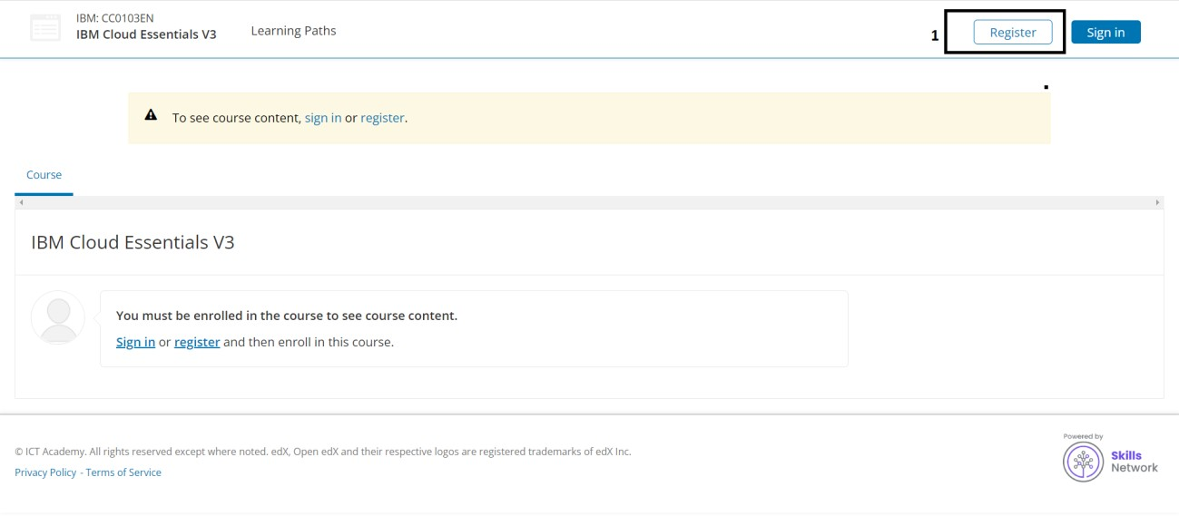

**Step-3:** Fill in the below details for creating an account.

* Full Name (Eg: John)
* Public Username (Eg: John1234)
* Email id (Eg: [john@gmail.com](mailto:john@gmail.com))
* Password (based on your choice)

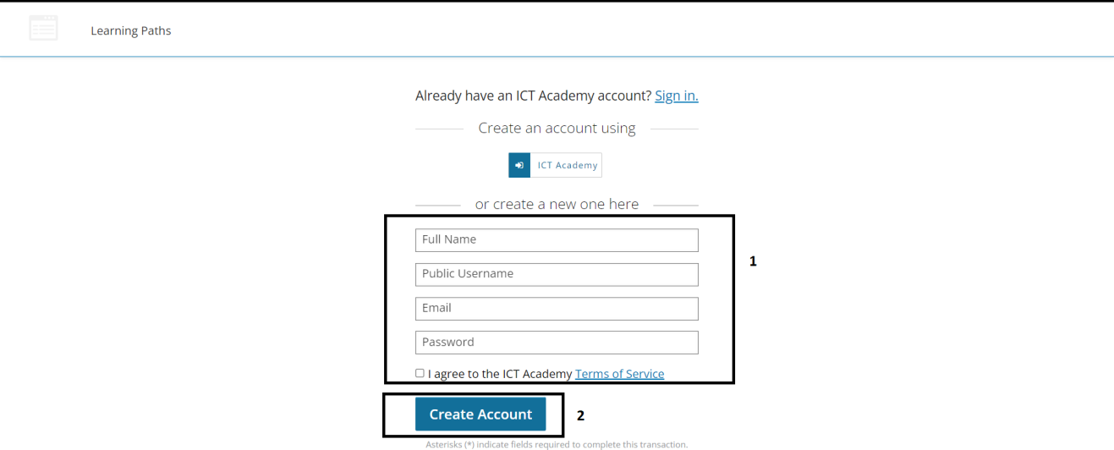

**Step-4:** Login to ICT Academy.

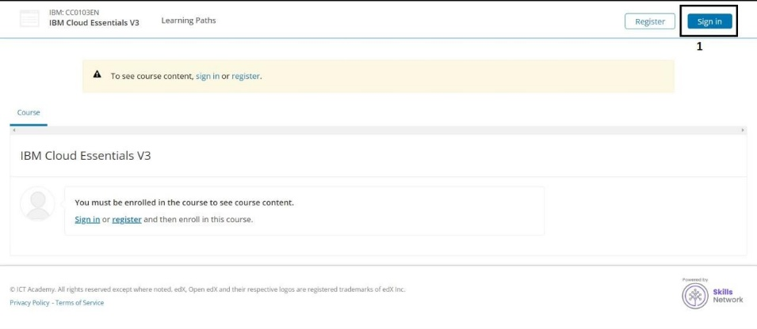

**Step-5:** Enter your registered email id & password then click on sign-in button.

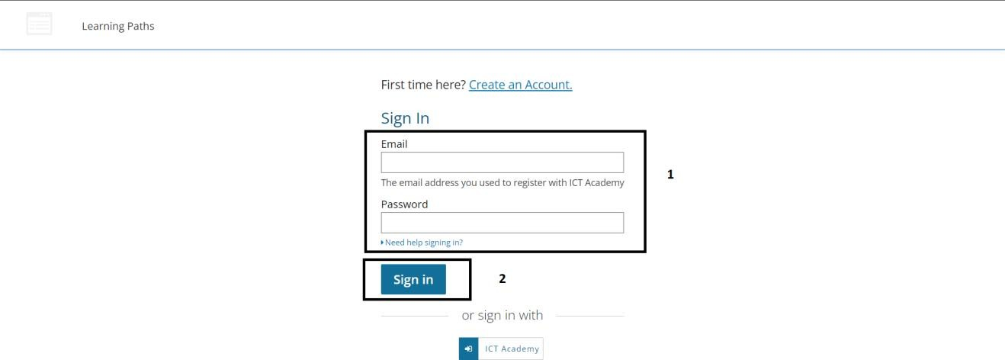

**Step-6:** Click on Enroll Now button to enter the course.

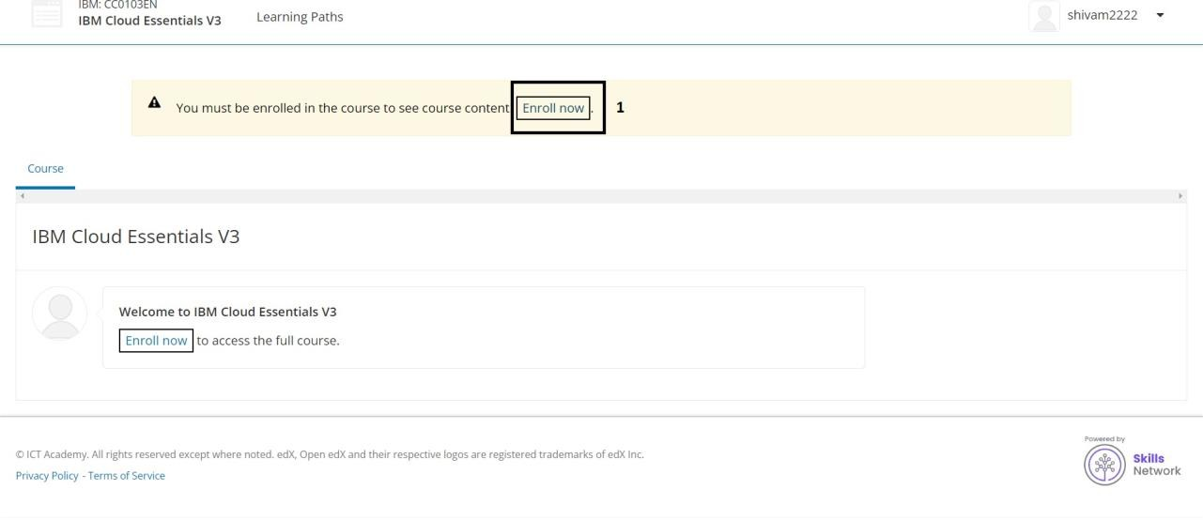

**Step-7:** Expand Module-1 and click on Obtain an IBM Cloud Feature Code.

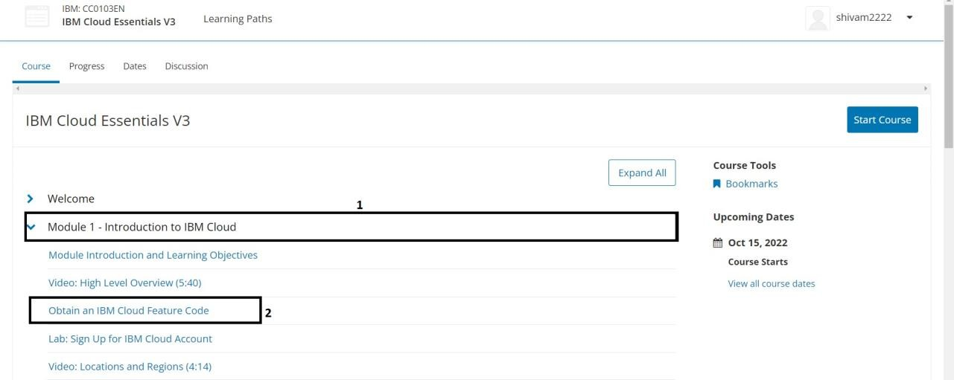

**Step-8:** Scroll down and click on the open tool to get the feature code for creating an IBM cloud account.

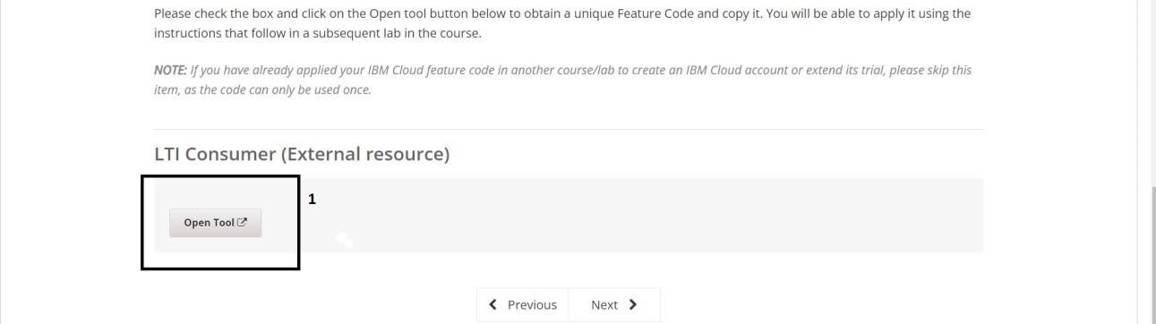

**Step-9:** Click ok on the popup message to proceed to the next page.

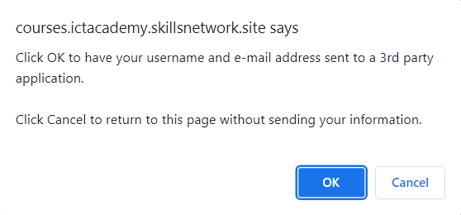

**Step-10:** Click on activate your trial account for 395 Days with the feature code.

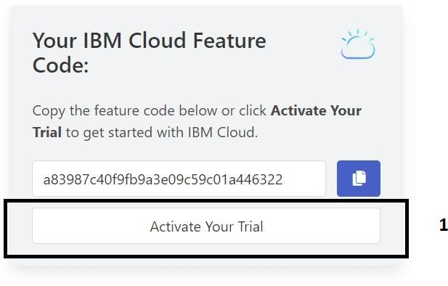

**Step-11:** Provide the same credentials i.e., email id & password used for ICT Academy account creation and click on next to get the OTP on the registered email id.

**Step-12:** Provide the received OTP on the registered email id and click on next.

**Step-13:** Provide personal information and click on next.

**Step-14:** Accept the terms and conditions then click on continue.

**Step-15:** Review account privacy notice mark the checkbox then click on continue.

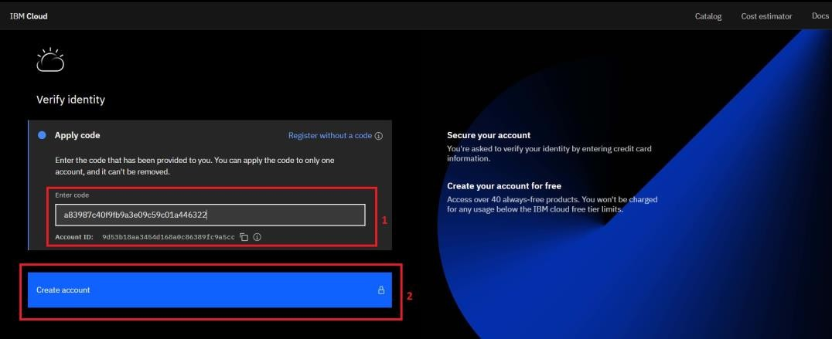

**Step-16:** Refer to Step-10 to copy the feature code or continue with the filled feature code then click on create account.

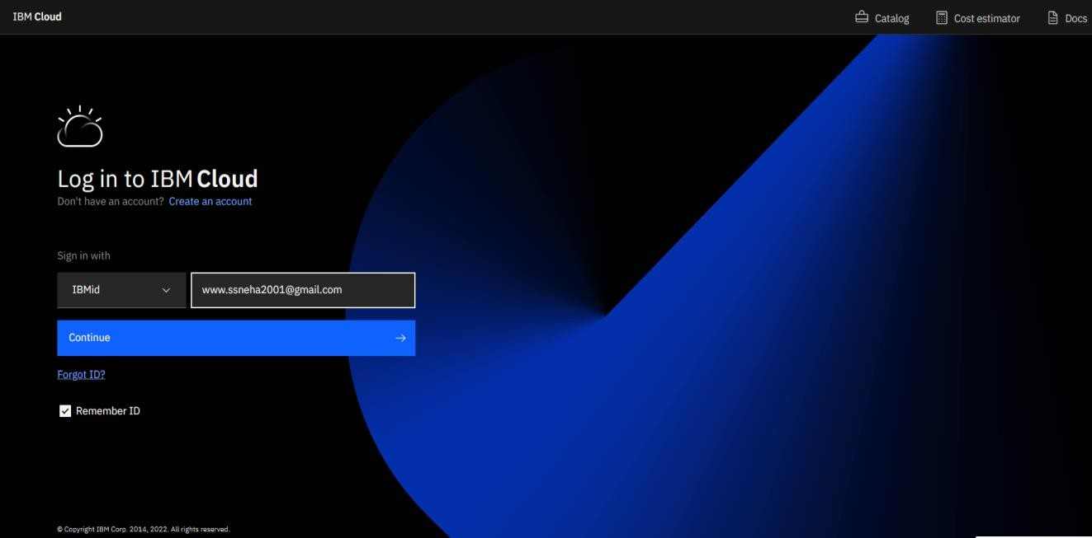

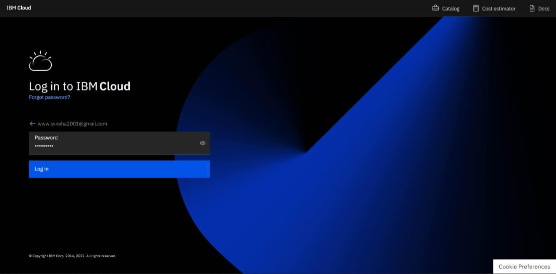

**Step-16:** After Successfully creating the account you are redirected to the dashboard page of the IBM Cloud account.

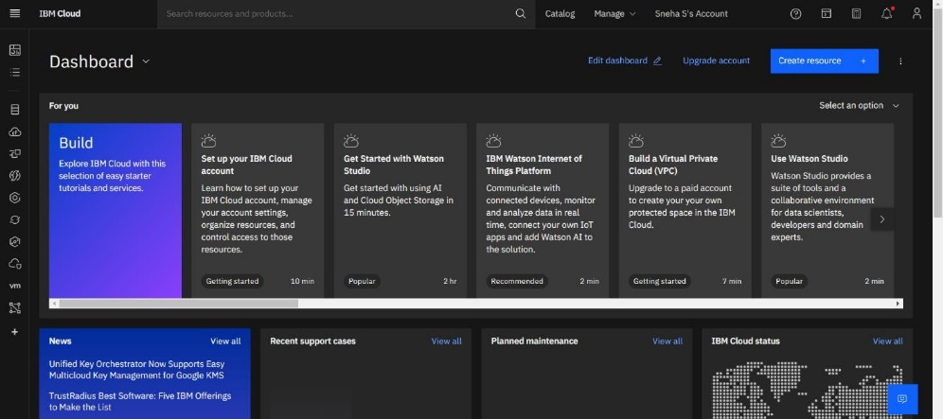

**Step-17:** To check the free trial details click on the manage dropdown from the top navigation bar and click on account.

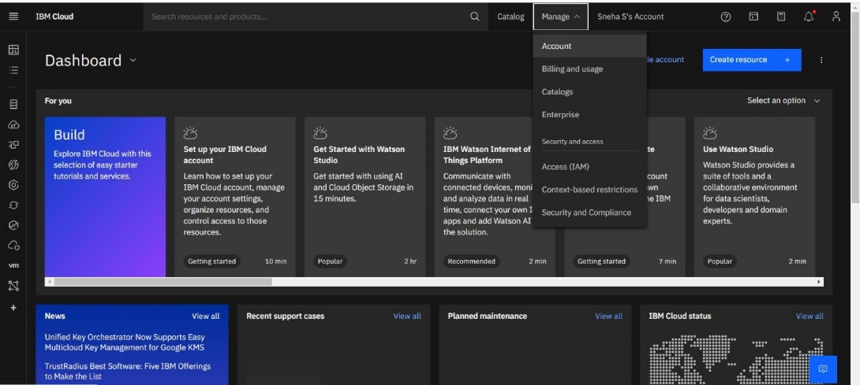

**Step-18:** Go to Account settings to check Free trial details.

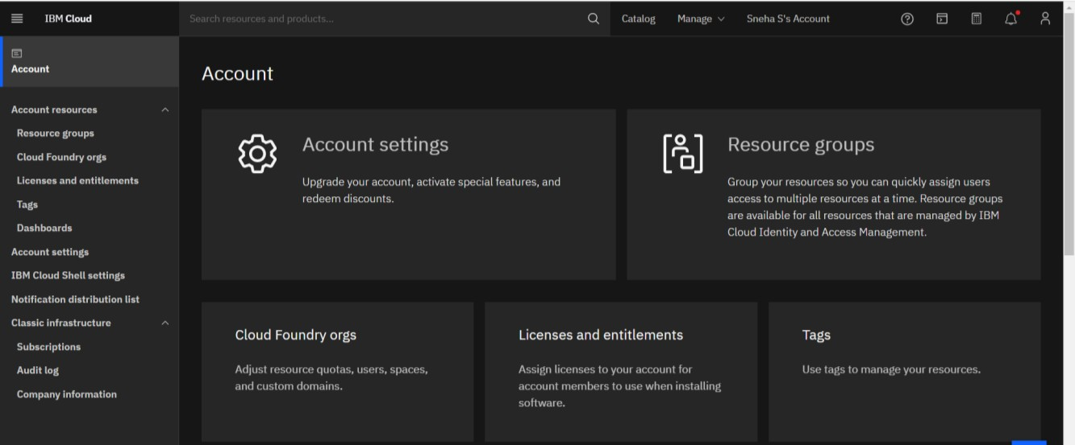

**Step-19:** Good Job! You created 395 Days Free trial account successfully.

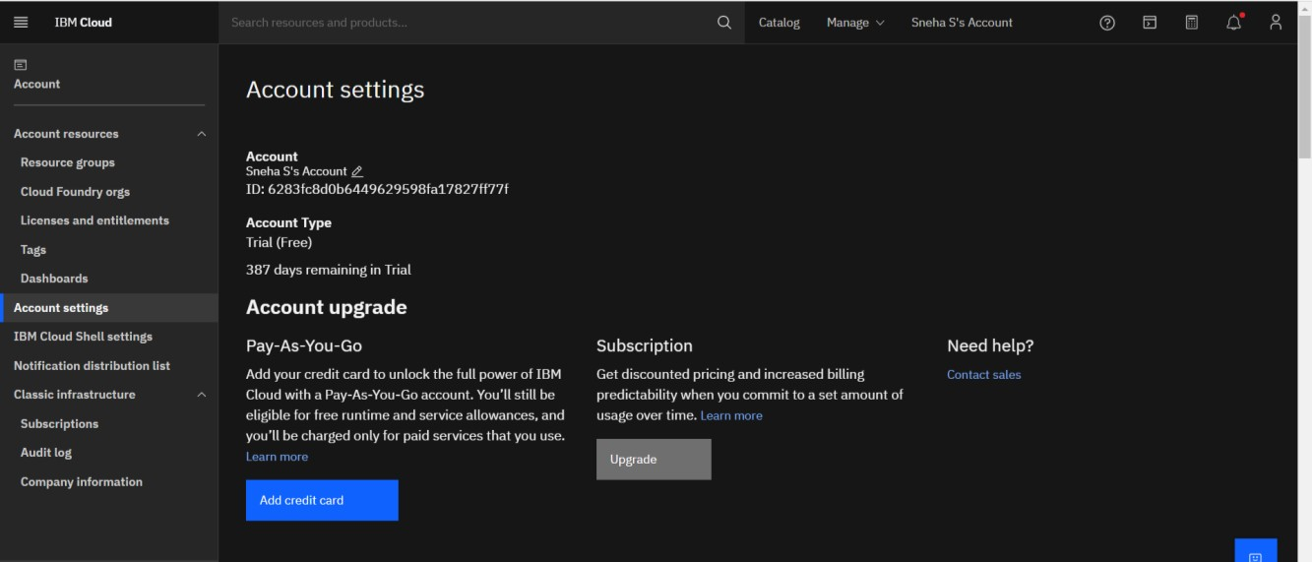

**OUTPUT:**

IBM Cloud account was created successfully.